**Newsletter June/July 2024**

**A reminder on your repeat prescriptions**

Patients on long term medication can order repeat prescriptions in the following ways:

**Online:** You can register for GP Online Services and order via the link at the top of the page on our website under prescriptions. And you can also visit our website for details on how to register with Patient Access under ‘Patient Access’ at the bottom of our landing page.

**In Person:** Tick the items required on your computerised prescription counterfoil and place in the letterbox located in the surgery entrance hall or at the entrance of the surgery labelled ‘prescription box’.

**By phone:** We have a 24-hour prescription order line. Please ring 01736 786925 and leave a message with your name, date of birth, address and what you would like to order on our phone line.

**By post:** send it to the Practice with a stamped addressed envelope if you want it posted back to you.

**By email:** By sending your request to [atlantic.prescriptions@nhs.net](mailto:atlantic.prescriptions@nhs.net)

Please allow two full working days for all repeat prescriptions to be issued whether you are a dispensing or a non-dispensing patient. Then dispensing a prescription takes a further two working days. Please remember to take bank holidays into account.

**Information regarding your referrals**

If you have had a referral made with your GP to the hospital and would like to know when you may be seen, please view the current waiting times via the link below.

[First Outpatient Appointment | Royal Cornwall Hospitals NHS Trust](https://royalcornwallhospitals.nhs.uk/waiting-times/first-outpatient-appointment/)

<https://royalcornwallhospitals.nhs.uk/waiting-times/first-outpatient-appointment/>

If you are concerned about your referral or have any questions regarding your referral, please contact the booking office who can advise you.

If you have had an urgent referral made, please contact the booking office on **01872 252323**

For all routine referrals, please contact the booking office on **01872 253409**



**How Pharmacies can help with Minor Illnesses**

Pharmacies can now help with simple minor illnesses and prescribe medicine without needing to see a GP for patients in the following eligible age ranges.

* Earache (1-17 years only)
* Impetigo (1year and over only)
* Infected Insect Bites

(1year and over only)

* Shingles (18years and over only)
* Sinusitis (12years and over only)
* Sore throat (5years and over only)
* Simple urinary tract infections

(women 16-64 years only)

**Services we provide**

Due to the high demand for joint injections and skin lesions, we have added specific clinics for these. Our joint injection clinics are running once a month, and our skin clinics are every two weeks in our evening clinics. We can pre book these appointments in advance, please contact the surgery to book an appointment.

Please note that if you would like to book an appointment for a steroid injection, you will need to either have discussed this with a GP prior to the appointment or have had a steroid injection in the past 12 months.

Our First Contact Physiotherapist is now on maternity leave, we do wish her all the best. We do have a First Contact Physiotherapist to cover her leave, please rest assured you will still be able to make an appointment with the Practice.

**Information for the School Holidays**

If you’re visiting Cornwall this half term or summer holiday and you need to speak to a GP, please contact your own surgery first.

They are used to helping by phone. If you need a prescription, your surgery can send it to any pharmacy you choose, for you to collect close to where you are staying.



**Self-help and Wellbeing**

Park Yoga in Penzance isa **FREE** outdoor activity where yoga sessions are available every Sunday in Penlee Park. This is open to people of all ages, backgrounds and abilities.

**Mental Health Hub**

If you would like additional support or would like to discuss any matters relating to your mental health, you can contact the Practice and an appointment can be made with the Penwith Mental Health Hub who offer face-to-face and telephone appointments.

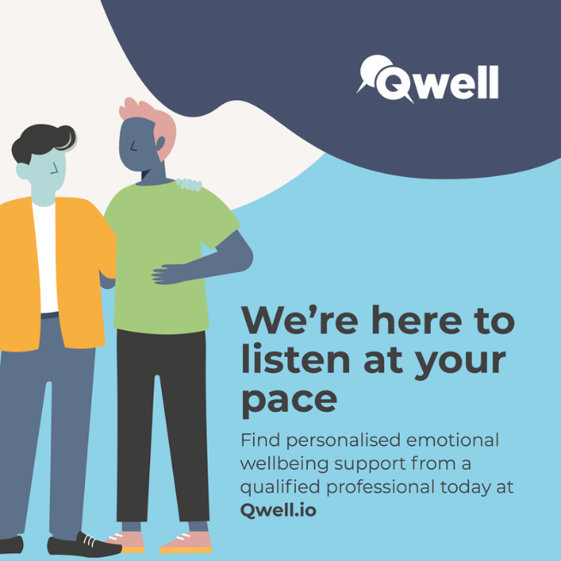

**Kooth and Qwell**

Qwell offers free mental wellbeing support for adults across the UK, when you need it, and for all adults.

As an NHS-funded service, you can get the help you need without worrying about how to meet the cost. With no waiting list or referral needed, you can sign up and access support today.

Visit their website here to find out more.

[Home - Qwell](https://www.qwell.io/)

<https://www.qwell.io>

