A reminder on your repeat prescriptions
We cannot accept a repeat prescription order over the telephone via option 1. If you would like to order by phone it must be option 2 for our automated prescription line or option 3 to speak with someone on our phone line.
Patients on long term medication can order repeat prescriptions in the following ways:
Online: You can register for GP Online Services and order via the link at the top of the page on our website under prescriptions. And you can also visit our website for details on how to register with Patient Access under ‘Patient Access’ at the bottom of our landing page.
In Person: Tick the items required on your computerised prescription counterfoil and place in the letterbox located in the surgery entrance hall or at the entrance of the surgery labelled ‘prescription box’.
By phone: We have a 24-hour prescription order line. Please ring 01736 786925 and leave a message with your name, date of birth, address and what you would like to order on our phone line.
By post: send it to the Practice with a stamped addressed envelope if you want it posted back to you.
By email: By sending your request to atlantic.prescriptions@nhs.net
Please allow two full working days for all repeat prescriptions to be issued whether you are a dispensing or a non-dispensing patient. Then dispensing a prescription takes a further two working days. Please remember to take bank holidays into account.

Your Digital Maternity Record
The online ephr system provides information for all midwifery contact numbers, trusted information, leaflets and maternal help groups while allowing the benefit if instant access to view your Maternity Record on any mobile device, tablet or PC throughout the duration of your pregnancy.
Ask your midwife about your digital Maternity Record or contact Maternity IT Monday – Friday 09:00am – 16:00pm on 01209 881788 or 075571723.
There are Online registrations available at
https://www.royalcornwall.nhs.uk/services/maternity-services/what-to-do-when-I-first-find-out-im-pregnant/
This allows you to complete your first booking information, complete your birth preferences plan and view your maternity notes.

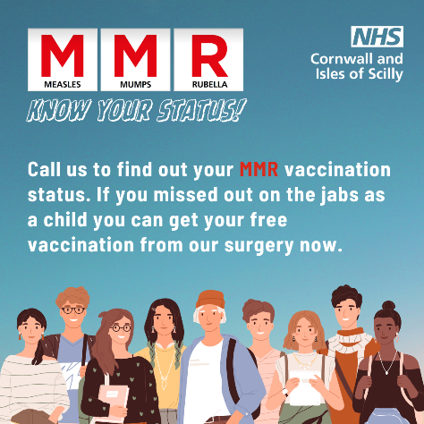
MMR Vaccines
You can contact your surgery to find out your MMR vaccination status. If you have missed out on your vaccinations as a child, you can get your free vaccination from your surgery.
You can contact the surgery and pre book an appointment with one of our nurses.

A reminder about test results
Please do not attend reception to ask for test results. Please telephone the surgery after 14:00 for all test results. Allow one week before contacting the surgery about the results of routine tests and x-rays. Smear results can take much longer and are posted to you.
Note that the Practice has a strict policy regarding confidentiality and data protection, and we will only release test results to the person to whom they relate to unless that person has given prior permission for the release of this data, or they are not capable of understanding the results. It is your responsibility to check your results and to make an appointment to discuss them with your doctor if you are advised to do so.

Kooth and Qwell
Kooth and Qwell offers free mental wellbeing support for adults across the UK, when you need it and for all adults.
As an NHS-funded service, you can get the help you need without worrying about how to meet the cost. With no waiting list or referral needed, you can sign up and access support today.
Visit their website here to find out more Home - Qwell

Pharmacies – and how they can help
Pharmacists can give you advice on a range of conditions and suggest medicines that can help.
They may also be able to offer treatment and some prescription medicine for some conditions, without you needing to see a GP. Conditions they can treat are:
- Earache (aged 1-17 years)
- Impetigo (aged 1 year and over)
- Infected insect bites (aged 1 year and over)
- Sinusitis (aged 12 years and over)
- Sore throat (aged 5 years and over)
- Shingles (aged 18 years and over)
- Urinary tract infections (women aged 16 to 64 years)
- Emergency contraception
If you go to a pharmacy with one of these conditions, the pharmacist will still offer you advice, treatment or refer you to a GP or other healthcare professional if needed.
They will then update your GP health record.

NHS Digital Weight Management Programme
